Class Design - Controller

# Create Initial Design Classes

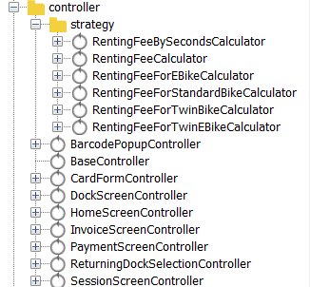

# Define Relationships Between Classes

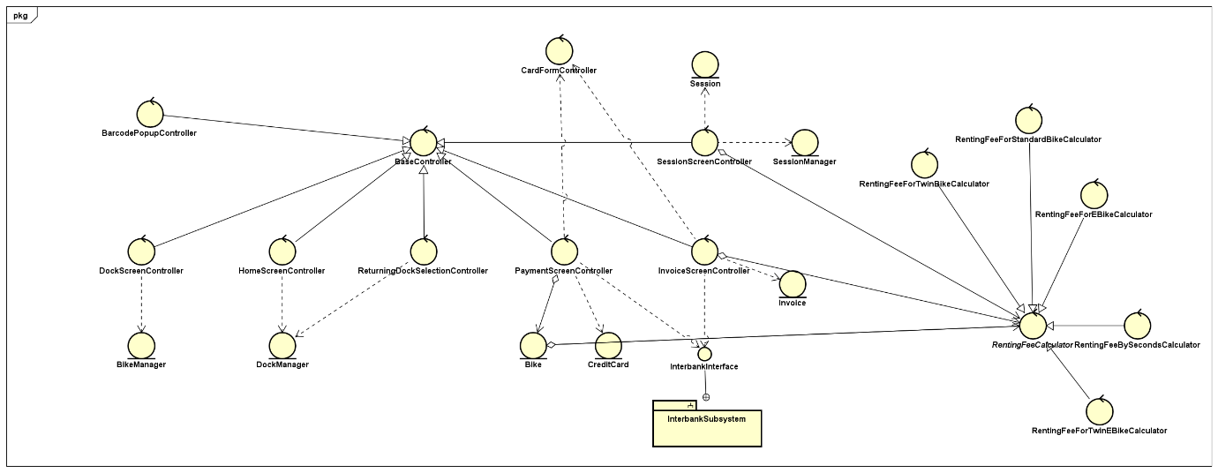

# Class Design

## Class “BaseController”

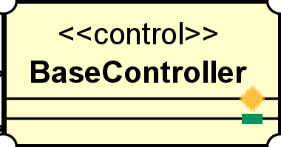

**Attribute**

None

**Operation**

None

**Parameter:**

None

**Exception:**

None

**Method**

None

**State**

None

## Class “BarcodePopupController”

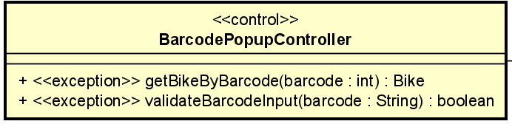

**Attribute**

None

**Operation**

|  |  |  |  |
| --- | --- | --- | --- |
| # | Name | Return type | Desciption |
| 1 | getBikeByBarcode | Bike | Get bike by using barcode |
| 2 | ValidateBarcodeInput | boolean | Checks if barcode is entered or not |

**Parameter:**

* Parameter of getBikeByBarcode()
* barcode– int
* Parameter of ValidateBarcodeInput()
* barcode - string

**Exception:**

* BarcodeNotFoundException
* NullBarcodeException
* InvalidBarcodeException

**Method**

None

**State**

None

## Class “DockScreenController”

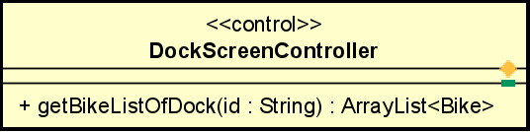

**Attribute**

None

**Operation**

|  |  |  |  |
| --- | --- | --- | --- |
| # | Name | Return type | Desciption |
| 1 | getBikeListOfDock | ArrayList<Bike> | Get bike list by using dock id |

**Parameter:**

* Parameter of getBikeListOfDock()
  + Id – dock id

**Exception:**

None

**Method**

None

**State**

None

## Class “HomeScreenController”

**Attribute**

None

**Operation**

|  |  |  |  |
| --- | --- | --- | --- |
| # | Name | Return type | Desciption |
| 1 | getDockList | ArrayList<Dock> | Get dock list |
| 2 | getDockListByKeyword | ArrayList<Dock> | Get dock list by keyword |

**Parameter:**

* Parameter of getDockListByKeyword()
* Text - keyword

**Exception:**

None

**Method**

None

**State**

None

## Class “InvoiceScreenController”

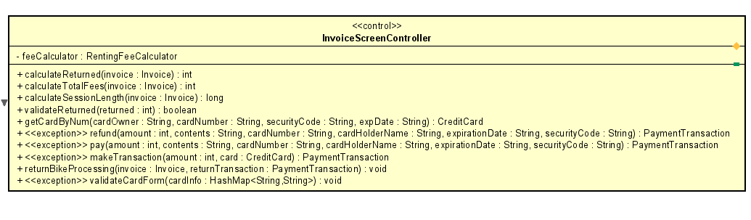

**Attribute**

|  |  |  |  |  |
| --- | --- | --- | --- | --- |
| # | Name | Data type | Default value | Description |
| 1 | feeCalculator | RentingFeeCalculator | new RentingFeeBySecondsCalculator | calculate fee |

**Operation**

|  |  |  |  |
| --- | --- | --- | --- |
| # | Name | Return type | Desciption |
| 1 | calculateReturned | Int | Calculate returned after deducting renting fees |
| 2 | calculateTotalFees | Int | Calculate total fees |
| 3 | calculateSessionLength | long | Session length |
| 4 | refund | PaymentTransaction | Create return transaction |
| 5 | validateReturned | boolean | Check returned validity |
| 6 | getCardByNum | CreditCard | Get credit card info |
| 7 | refund | PaymentTransaction | Setup Return transaction |
| 8 | pay | PaymentTransaction | Setup transaction |
| 9 | makeTransaction | PaymentTransaction | Proceed transaction |
| 10 | returnBikeProcessing | void | Process return bike |
| 11 | validateCardForm | void | Check card form validity |

**Parameter:**

* Parameter of calculateReturned()
* Invoice
* Parameter of calculateTotalFees()
* Invoice
* Parameter of calculateSessionLength()
* Invoice
* Amount Parameter of getCardByNum()
  + cardOwner
  + cardNumber
  + securityCode
  + expDate
* Parameter of refund()
* amount
* contents
* cardNumber
* cardHolderName
* expirationDate
* securityCode
* Parameter of pay()
* amount
* contents
* cardNumber
* cardHolderName
* expirationDate
* securityCode
* ExpirationDate Parameter of makeTransaction()
* amount
* card
* Parameter of validateReturned()
* returned
* Parameter of returnBikeProcessing()
* Invoice
* returnTransaction
* Parameter of validateCardForm()
* cardInfo

**Exception:**

PaymentException

NullCardNumberException

NullCardOwnerException

NullExpDateException

NullSecurityCodeException

CardExpiredException

**Method**

None

**State**

None

## Class “PaymentScreenController”

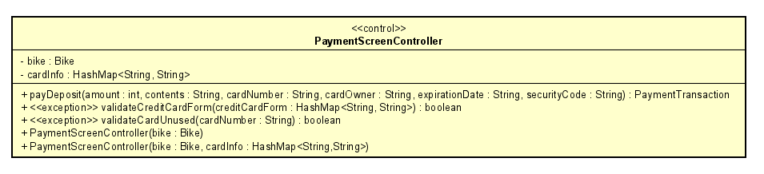

**Attribute**

|  |  |  |  |  |
| --- | --- | --- | --- | --- |
| # | Name | Data type | Default value | Description |
| 1 | bike | Bike | NULL | bike |
| 2 | cardInfo | HashMap<String, String> | NULL | Card info |

**Operation**

|  |  |  |  |
| --- | --- | --- | --- |
| # | Name | Return type | Desciption |
| 1 | payDeposit | PaymentTransaction | Set rent transaction |
| 2 | validateCreditCardForm | boolean | Check creditcard form |
| 3 | validateCardUnused | boolean | Check creditcard used or not |

**Parameter:**

* Parameter of payDeposit()
* amount
* contents
* cardNumber
* cardOwner
* expirationDate
* securityCode
* Parameter of validateCreditCardForm()
  + creditCardForm
* Parameter of validateCardUnused()
  + cardNumber

**Exception:**

None

**Method**

None

**State**

None

## Class “ReturningDockSelectionController”

**Attribute**

None

**Operation**

|  |  |  |  |
| --- | --- | --- | --- |
| # | Name | Return type | Desciption |
| 1 | getDockList | ArrayList<Dock> | Get dock list |
| 2 | getDockListByKeyWord | ArrayList<Dock> | Get dock list by keyword |
| 3 | createInvoice | Invoice | Create new invoice |
| 4 | returnBikeToDock | void | Return bike to the chosen dock |

Parameter:

* Parameter of getDockListByKeyWord()
  + keyword
* Parameter of createInvoice()
  + id
* Parameter of returnBikeToDock()
  + bike
  + dock

**Exception:**

None

**Method**

None

**State**

None

## Class “SessionScreenController”

**Attribute**

None

**Operation**

|  |  |  |  |
| --- | --- | --- | --- |
| # | Name | Return type | Desciption |
| 1 | returnBike | boolean | Check if bike is available |
| 2 | calculateCurrenRentingFees | int | Calculate current renting fees |
| 3 | calculateSessionLength | long | Calculate session length |

**Parameter:**

* Parameter of returnBikeToDock()
  + session
  + dock
* Parameter of returnBikeToDock()
  + session
* Parameter of returnBikeToDock()
  + session

**Exception:**

None

**Method**

None

**State**

None

## Class “CardFormController”

**Attribute**

None

**Operation**

|  |  |  |  |
| --- | --- | --- | --- |
| # | Name | Return type | Desciption |
| 1 | validateCreditCardForm | boolean | Check if card is valid |
| 2 | validateCardNumber | boolean | Validate card number |
| 3 | validateCardOwner | boolean | Validate card owner |
| 4 | validateSecurityCode | boolean | Validate security code |
| 5 | validateExpDate | boolean | Validate exp date |

**Parameter:**

* Parameter of validateCreditCardForm()
  + creditCardForm
* Parameter of validateCardNumber()
  + CardNumber
* Parameter of validateCardOwner()
  + cardOwner
* Parameter of validateSecurityCode()
  + securityCode
* Parameter of validateExpDate()
  + expDate

**Exception:**

None

**Method**

None

**State**

None

## Class “RentingFeeCaculator”

**Attribute**

None

**Operation**

|  |  |  |  |
| --- | --- | --- | --- |
| # | Name | Return type | Desciption |
| 1 | calculateCurrentRentingFees | int | Calculate current renting fees |
| 2 | calculateTotalFees | int | Calculate total fees |

**Parameter:**

* Parameter of calculateCurrentRentingFees()
  + session
* Parameter of calculateTotalFees()
  + invoice

**Exception:**

None

**Method**

None

**State**

None

## Class “RentingFeeForEBikeCalculator”

**Attribute**

None

**Operation**

|  |  |  |  |
| --- | --- | --- | --- |
| # | Name | Return type | Desciption |
| 1 | calculateCurrentRentingFees | int | Calculate current renting fees |
| 2 | calculateTotalFees | int | Calculate total fees |

**Parameter:**

* Parameter of calculateCurrentRentingFees()
  + session
* Parameter of calculateTotalFees()
  + invoice

**Exception:**

None

**Method**

None

**State**

None

## Class “RentingFeeForTwinEBikeCalculator”

**Attribute**

None

**Operation**

|  |  |  |  |
| --- | --- | --- | --- |
| # | Name | Return type | Desciption |
| 1 | calculateCurrentRentingFees | int | Calculate current renting fees |
| 2 | calculateTotalFees | int | Calculate total fees |

**Parameter:**

* Parameter of calculateCurrentRentingFees()
  + session
* Parameter of calculateTotalFees()
  + invoice

**Exception:**

None

**Method**

None

**State**

None

## Class “RentingFeeForTwinBikeCalculator”

**Attribute**

None

**Operation**

|  |  |  |  |
| --- | --- | --- | --- |
| # | Name | Return type | Desciption |
| 1 | calculateCurrentRentingFees | int | Calculate current renting fees |
| 2 | calculateTotalFees | int | Calculate total fees |

**Parameter:**

* Parameter of calculateCurrentRentingFees()
  + session
* Parameter of calculateTotalFees()
  + invoice

**Exception:**

None

**Method**

None

**State**

None

## Class “RentingFeeForStandardBikeCalculator”

**Attribute**

None

**Operation**

|  |  |  |  |
| --- | --- | --- | --- |
| # | Name | Return type | Desciption |
| 1 | calculateCurrentRentingFees | int | Calculate current renting fees |
| 2 | calculateTotalFees | int | Calculate total fees |

**Parameter:**

* Parameter of calculateCurrentRentingFees()
  + session
* Parameter of calculateTotalFees()
  + invoice

**Exception:**

None

**Method**

None

**State**

None

## Class “RentingFeeBySecondsCalculator”

**Attribute**

None

**Operation**

|  |  |  |  |
| --- | --- | --- | --- |
| # | Name | Return type | Desciption |
| 1 | calculateCurrentRentingFees | int | Calculate current renting fees |
| 2 | calculateTotalFees | int | Calculate total fees |

**Parameter:**

* Parameter of calculateCurrentRentingFees()
  + session
* Parameter of calculateTotalFees()
  + invoice

**Exception:**

None

**Method**

None

**State**

None